

project report

Development of a Multi-Source Deep Learning Model for Stock Market Prediction on JCI

JORDAN THEOVANDY

23.K1.0018

Faculty of Computer Science

Soegijapranata Catholic University

2026

Table of Contents
Chapter 1. Introduction 2
Chapter 2. Research Method 5
2.1. Research Data 6
2.2. Data Preprocessing 7
2.3. Temporal Alignment & Labeling 8
2.4. Proposed Model 9
2.5. Experimental Setup 11
2.6. Experimental Scenario 11
2.7. Evaluation Metrics 12
List of Figures
Figure 1. Big Picture Architecture 5

List of Tables
Table 1. Sample Table of JCI Price Data 2018-2025 6
Table 2. Sample Table of USD/IDR Exchange Rates for 2025 6
Table 3. Sample Table of BI-Rate Data for 2025 6
Table 4. Sample Table of Inflation Data for 2025 7
Table 5. Architecture Specifications of the Proposed Hybrid Model 10

Introduction
The stock market, especially like JCI, is basically a huge indicator for Indonesia's economy. It easily shows how healthy all those listed Indonesian companies actually are [1]. Predicting movements in the JCI is a fundamental challenge due to the complex, nonlinear, and dynamic structure of the data [1, 2]. Specifically, the Indonesian stock market exhibits the characteristics of a regime shift, a phenomenon in which the statistical distribution of data changes structurally as a result of macroeconomic events such as changes in interest rates, exchange rate volatility, or global crises [3].
In reality, the JCI’s movements are influenced not only by historical price data, but also by macroeconomic indicators (such as the dollar exchange rate, inflation data, and the BI Rate) and the financial news in Indonesia. [1, 4]. Challenge how to effectively integrate this heterogeneous data from multiple sources [4]. The use of a Multi-Layer Perceptron (MLP) has proven to be highly effective for extracting features from static macroeconomic data in order to capture patterns of nonlinear interactions among variables before further processing [5]. Meanwhile, the Long Short Term Memory (LSTM) model is needed to capture the temporal dependencies in technical data (time series data) [4, 6]. Language models like IndoBERT have already proven their excellence in terms of understanding the local context from Indonesian financial news compared to traditional models [7].
In this research, predicting the stock market could be classified into a couple main categories. The process starts by extracting the statistics method and traditional machine learning as a baseline model. Models like ARIMA and Moving Average are more often used as a fundamental, but it has a limitation to handle long term dependencies [8]. Algorithms like Linear Regression, SVM, and Random Forest are common and useful to catch the non-linear pattern, although the performance is often on par with random guessing in highly volatile market conditions [3].

The next part is financial news analytics based on Transformer. Research by Arnanda & Rahma (2024) reporting the accuracy is 88,60% use IndoBERT-large models on primary dataset like detik.com in 2018-2024 period time. This achievement was validated using a relatively balanced label distribution, where the model significantly outperformed the SVM baseline, which achieved an accuracy of only 82.10% on the same data [9]. The use of a MLP has proven effective for extracting features from macroeconomic tabular or static data to capture non linear interactions between variables prior to their integration into sequential modeling [5].

Although fuzzy adaptive techniques like Adaptive Multidimensional Fusion Network (AMFN) are already developed, it has methodology distances for handling Indonesia stock market dynamically [11]. However, tree based mechanisms often struggle to capture high dimensional, continuous, non linear feature interactions in real-time compared to differentiable artificial neural network structures [1]. This study addresses that gap by proposing the use of an MLP as a Soft Gating Network, which offers greater flexibility in modeling volatility patterns, free from the discrete partitioning constraints found in decision tree algorithms. This research integrates the IndoBERT language model, which has demonstrated superior performance over traditional models in capturing the nuances of local financial news regarding the JCI [3, 7].
This study aims to develop a resilient JCI prediction system through adaptive signal fusion. To accomplish this, the following specific objectives are proposed. Implement a Multi-Layer Perceptron (MLP) as a feature extractor for tabular macroeconomic variables [5]. Build a technical feature branch using Long Short-Term Memory (LSTM) and a news feature branch using Frozen IndoBERT for semantic feature extraction [4, 7]. Develop an Adaptive MLP Fusion layer as a dynamic weight generator to improve prediction stability, with the goal of achieving a significantly higher F1-Score and Sharpe Ratio, which is expected to yield better performance compared to the relevant baseline model like LSTM model as a representation of a deep learning approach based on technical data.
Guide the investigation toward these objectives, this study addresses the following research questions. The question is to how does the integration of an MLP feature extractor for macroeconomic variables affect the classification accuracy and F1-Score compared to direct input? To what extent does the inclusion of Frozen IndoBERT semantic representations improve directional (UP/DOWN) prediction accuracy compared to a purely technical baseline? Does the Adaptive MLP Fusion (Soft Gating) mechanism yield superior risk-adjusted returns (Sharpe Ratio) and stability compared to conventional static fusion or baseline models?
Ensure a focused investigation, this research is subject to several limitations. From the data side, this research used daily closing prices of JCI period 2018-2025 from Yahoo Finance [1, 3], official macro economy data from BI and BPS, and Indonesia financial news corpus from detik.com, CNBC Indonesia and Kontan [7, 9]. From the model side, this research focuses on MLP, LSTM, and IndoBERT architecture, with an output like the price movement prediction for a specific 5 days forward horizon [1, 2]. A 5-day horizon is selected to capture short-to-medium-term momentum while filtering out daily micro-structure noise and high-frequency trading anomalies specific to the JCI. This research does not include techniques like Reinforcement Learning or Diffusion Models to keep computational efficiency and interpretability models [2, 10].
Improve model generalization, early stopping is employed throughout the training process to limit overfitting. The IndoBERT-base was chosen because the model size is smaller than the large variant, so it can be more efficient for computability [1].

Research Method
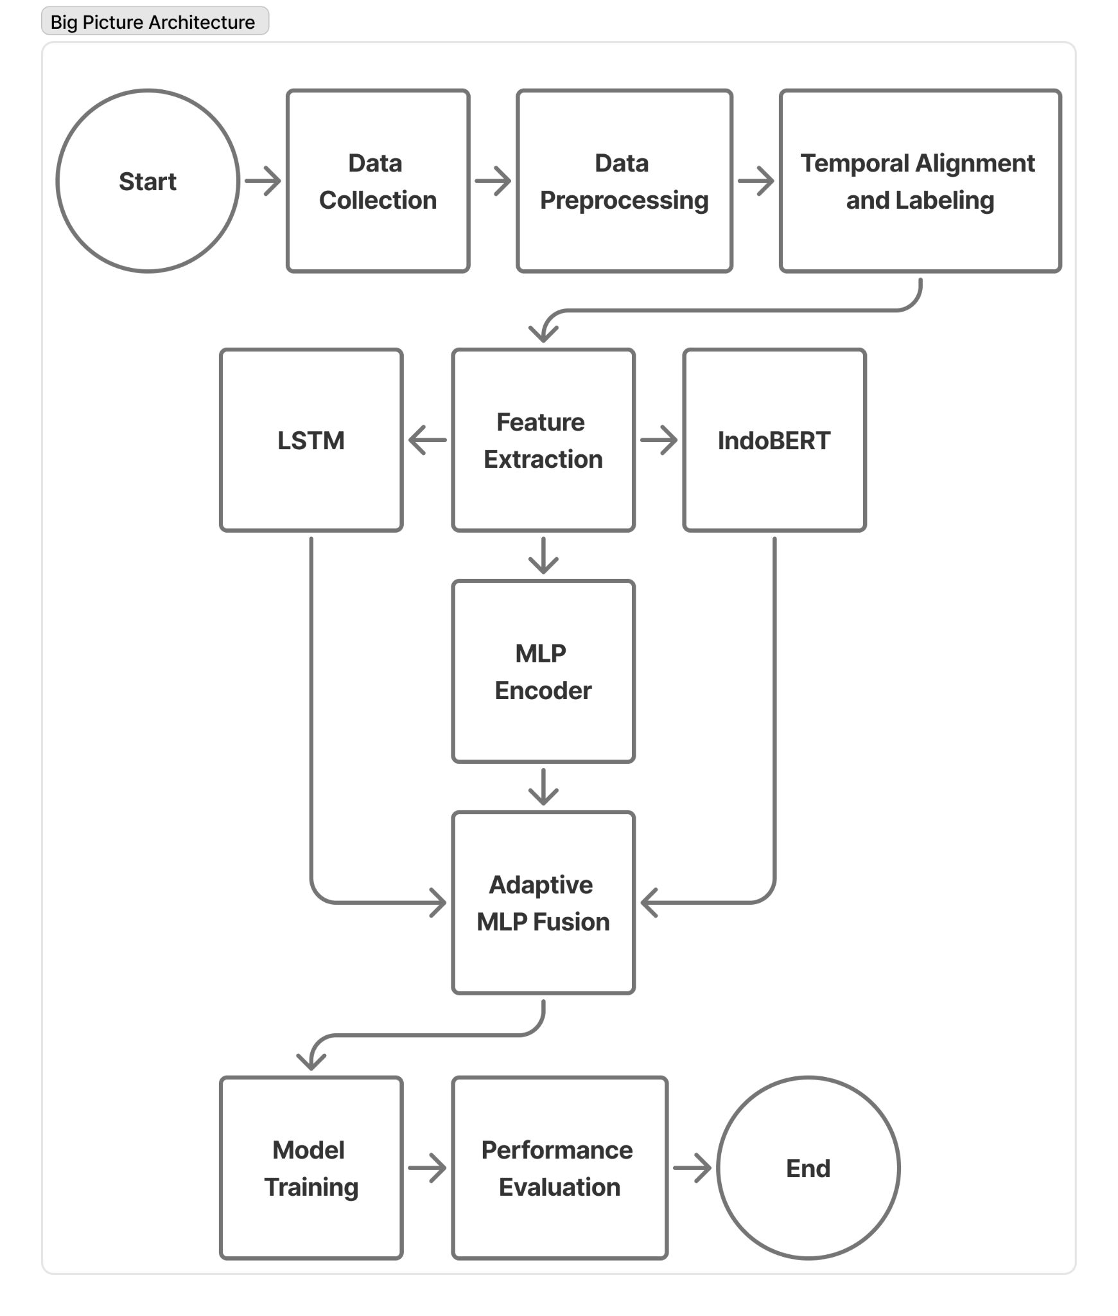
Figure 1. Big Picture Architecture
This study shows a machine learning pipeline that brings together heterogeneous data from multiple sources to enable adaptive JCI movement prediction. The system flow begins with the Data Collection phase (technical, macroeconomic, and financial news) and then goes through the Data Preprocessing phase (cleaning and normalization), transforming raw data that is irregular, incomplete, or messy into clean data ready for analysis. Crucial phases include Temporal Alignment and Labeling to ensure cross-domain data synchronization based on the stock exchange calendar. The proposed architecture utilizes an Adaptive MLP Fusion layer the parallel feature extraction process that combines the IndoBERT, LSTM, and MLP Encoder models, where the resulting feature representations are then fused by an Adaptive MLP Fusion layer designed to adapt to changing market characteristics through a dynamic weighting mechanism. The entire system concludes with a Performance Evaluation phase using Walk-Forward Validation and statistical and economic metrics-based evaluations to ensure model feasibility.

Research Data
The main one representing time-series data is the JCI Price Data (daily Open, High, Low, Close, and Volume (OHLCV)) from Yahoo Finance, the structure of which is detailed in Table 1.
Table 1. Sample Table of JCI Price Data for 2018–2025
Date | Close | High | Low | Open | Volume
2018-01-02 | 6339.24 | 6445.91 | 6326.09 | 6366.08 | 52168200.00
2018-01-03 | 6251.48 | 6342.19 | 6220.69 | 6341.27 | 48866400.00
2018-01-04 | 6292.32 | 6292.32 | 6233.94 | 6257.72 | 57864900.00
2018-01-05 | 6353.74 | 6353.74 | 6278.72 | 6279.46 | 74223700.00
2018-01-08 | 6385.40 | 6385.40 | 6349.04 | 6354.36 | 66702400.00
The next data is Macroeconomic Data indicators (BI-Rate, Inflation, and USD/IDR Exchange Rate) from Bank Indonesia and Statistics Indonesia (BPS) whose detailed structure can be seen in Table 2 for an example of US/IDR Exchange Rate data, Table 3 for an example of BI-Rate data, and Table 4 for an example of Inflation data.
Table 2. Sample Table of USD/IDR Exchange Rates for 2025
No | Date | Exchange Rate
1 | 12/31/2025 12:00:00 AM | 16,720
2 | 12/30/2025 12:00:00 AM | 16,782
3 | 12/29/2025 12:00:00 AM | 16,788
4 | 12/24/2025 12:00:00 AM | 16,767
5 | 12/23/2025 12:00:00 AM | 16,790

Table 3. Sample Table of BI-Rate Data for 2025

No | Date | BI-7Day-RR
1 | 17 December 2025 | 4.75 %
2 | 19 November 2025 | 4.75 %
3 | 22 October 2025 | 4.75 %
4 | 17 September 2025 | 4.75 %
5 | 20 August 2025 | 5.00 %

Table 4. Sample Table of Inflation Data for 2025
No | Period | Inflation Data
1 | January 2025 | 0.76 %
2 | February 2025 | -0.09 %
3 | March 2025 | 1.03 %
4 | April 2025 | 1.95 %
5 | May 2025 | 1.6 %

And the last data is Financial News Data or News Text Data consists of Indonesian-language online news text collected through web scraping from local economic portals such as detik.com, CNBC Indonesia, and Kontan. Citing Arnanda & Rahmah (2024), news filtration was carried out using the keyword "IHSG" to filter relevant information, which has been shown to significantly improve the accuracy of the Transformer model [3, 6].
All of these dataset categories represent the internal and external dimensions of the market to provide a holistic view of the stock exchange dynamics during the period 2018 to 2025. The selection of 2018 was based on the stability of the high-quality news corpus for IndoBERT training, while the 2020–2021 period was used to test the resilience of the Adaptive MLP Fusion architecture to regime shifts due to the global anomaly of COVID-19.

Data Preprocessing
Data Preprocessing stage is carried out to transform heterogeneous variables into a uniform tensor format without information leakage. This process includes a couple steps. Technical Feature Extraction process is carried out by converting raw market data into a set of features that represent daily technical conditions. The features used include the Relative Strength Index (RSI-14) to identify overbought and oversold conditions, the Moving Average Convergence Divergence (MACD) and Signal Line to represent trends and momentum, the Average True Range (ATR-14) to measure market volatility, and the Simple Moving Average (SMA-20) to capture short-term trend direction. In addition, the normalized closing price (Close) and trading volume (Volume) are also used as input features. All numeric features are then normalized using Min-Max Scaling, where the scaler fitting process is performed only on the training data (training set) and then applied to the validation and testing data to avoid data leakage and maintain the consistency of the model training process [4, 7].
Macro Data Alignment which aligns monthly published macroeconomic data to the daily scale of the stock exchange using the Forward Fill (Last Observation Carried Forward) method, so that each trading day uses the latest officially available macroeconomic values. News Preprocessing and Tokenization, which cleans text data by removing HTML tags, URLs, and excess spaces before processing using the IndoBERT Tokenizer. Next, each article is converted into an embedding representation using the IndoBERT pretrained model, and all embeddings originating from the same publication date are aggregated using mean pooling to produce a single daily semantic representation vector.

  - Temporal Alignment & Labeling
After all data sources have gone through the preprocessing stage, a Temporal Alignment and Labeling process is performed to align technical, macroeconomic, and news data based on the time dimension before being used in the model training process. Time Synchronization is performed by matching data based on trading dates (date-based synchronization), where available macroeconomic data in monthly frequencies is first aligned to the daily scale using the Forward Fill method. News published on Saturdays and Sundays is allocated to the next trading day (Monday) to represent the accumulation of information during market close. If there is no relevant news available on a trading day, a zero-vector embedding is used to represent the absence of textual information. Then sets a binary prediction target with a five day trading horizon $(t+5)$, where label 1 (UP) is assigned if the closing price at time $t+5$ is higher than the closing price at time $t$, while label 0 (DOWN) is assigned for the opposite condition. Walk Forward Validation is applied by dividing the data chronologically so that the training data always precedes the validation and testing data to avoid look-ahead bias and maintain the validity of the evaluation in the time series prediction scenario.

Proposed Model
This research proposes a hybrid end-to-end machine learning pipeline architecture that systematically integrates heterogeneous multi-source data processing into an adaptive JCI movement prediction system. This system executes several branches of feature extraction independently and simultaneously to process different data characteristics:
- Technical (LSTM Train from Scratch): Used to study temporal patterns from market data consisting of closing prices (Close), trading volume (Volume), and technical indicators such as RSI, MACD along with Signal Line, ATR, and SMA using 28 days Lookback Window to represent technical features.
- Macroeconomics (MLP Encoder Train from Scratch): Used to learn the non-linear relationship between the BI Rate, inflation rate, and USD/IDR exchange rate through a multilayer perceptron to produce a more informative Latent Representation before the multimodal fusion process. Unlike the technical branch that uses a 28 days Lookback Window to capture temporal patterns, the macroeconomic branch does not use a lookback window. Each observation is represented by a couple macroeconomic variables at time $t$, namely the BI Rate, inflation rate, and USD/IDR exchange rate. This approach was chosen because macroeconomic variables have a relatively low frequency of change so that the use of a long temporal window has the potential to produce information redundancy.
- Financial News (Frozen IndoBERT Pretrained): Used to extract semantic representations from financial news texts using a frozen pretrained IndoBERT model so that contextual information from the news can be utilized as embedding in the adaptive fusion process. This model has been trained on a large-scale Indonesian language corpus. Frozen IndoBERT is used to capture semantic information and linguistic context contained in financial news without performing an explicit sentiment classification process. It is used only as a feature extractor, to keep the research focus on Adaptive MLP Fusion, not on improving IndoBERT.
The main contribution of this study is an Adaptive MLP Fusion method that employs a Soft Gating Network for adaptive feature fusion. This mechanism functions as a dynamic weight generator that automatically generates weighting coefficients (α, β, γ) for each information source based on the characteristics of the input data. This allows the model to adaptively adjust the relative contributions of technical, macroeconomic, and news features to each market condition, thereby increasing the model's flexibility in addressing market dynamics and changing characteristics (regime shifts).
Details of the model configuration, layers, and technical specifications used are presented in Table 5.
Table 5. Architectural Specifications of the Proposed Hybrid Model
Model | Layer | Technical Specifications
Frozen IndoBERT | Base Model | 12 Layers, 12 Attention Heads, Hidden Size 768 (Frozen)
 | Projection Layer | Linear Layer (768 → 64)
LSTM Branch | LSTM | Hidden Size 64, Lookback Window 28, Dropout 0.2
MLP Encoder | Hidden Layers | 2 Layers (3 → 32 → 16), ReLU
 | Output Feature | 16-dimensional embedding
Adaptive MLP Fusion (Soft Gating Network) | Input | 144 (64 + 16 + 64)
 | Output | 3 weights (α, β, γ) via Softmax

Experimental Setup
The experiments in this study were conducted using a combination of a local computation environment and a cloud computing platform to ensure the model training process can run efficiently and consistently. A personal computer was used as the development and implementation environment, while the model training process requiring high computing resources was run on cloud computing platforms such as Google Colab or Kaggle Notebooks that provide GPU acceleration. In terms of software, this study used the Windows operating system with the Python 3.11 programming language. Model implementation was carried out using the PyTorch framework due to its flexibility in building the Adaptive MLP Fusion architecture and Soft Gating Network mechanism, as well as the Hugging Face Transformers library for integrating the Frozen IndoBERT model as a semantic representation extractor for financial news.

Experimental Scenario
Validating the model chronologically, an expanding window Walk-Forward mechanism is implemented with a scheme to evaluate the model chronologically according to the characteristics of the time series data. At each iteration, the model is trained using all available historical data up to a specific period, then evaluated on the next period. This approach was chosen to avoid look-ahead bias and simulate prediction conditions more closely to real-world implementation.
To evaluate the effectiveness of the proposed model, a comparison was conducted against a pure LSTM that utilizes only technical features as the primary baseline. The comparison was conducted using the same training and testing scenarios so that the evaluation results could be analyzed consistently. An ablation study was conducted to evaluate the contribution of each information source to model performance. The configurations tested included:
- LSTM based on technical features only,
- LSTM with additional macroeconomic features,
- LSTM with additional news features,
- LSTM with technical, macroeconomic, and news features without an Adaptive Soft Gating mechanism, and the complete proposed model that integrates all components through Adaptive Soft Gating
This analysis aimed to identify the relative contribution of each modality and evaluate the effect of the Adaptive Soft Gating mechanism on overall model performance.

Evaluation Metrics
The model's performance in predicting the JCI's movement direction over a $t+5$ horizon was evaluated using binary classification metrics consisting of Accuracy, F1-Score, and ROC-AUC. Accuracy measures the proportion of correct predictions, F1-Score balances precision and recall, and ROC-AUC evaluates the model's ability to distinguish between UP and DOWN classes.
In addition to classification metrics, this study also used the Sharpe Ratio and Maximum Drawdown to evaluate the quality of the model's investment signals through simple trading strategy simulations. The Sharpe Ratio measures risk-adjusted returns, while Maximum Drawdown measures the maximum decline in portfolio value during the testing period.

Result and Discussion

Results

Predictive Performance Evaluation (Classification Metrics)
// baseline vs proposed model: Present a clean table comparing your Proposed Model against the Baselines (Pure LSTM, LSTM+Macro, LSTM+News, LSTM+Static Fusion). Include Accuracy, F1-Score, Precision, Recall, and ROC-AUC.
// ablation study analysis: discuss the table from baseline comparasion, which brand added the most value? (e.g., “adding news improved recall by X%, indicating news helps catch sudden upward momentum…”)
// confusion matrix analysis: show the confusion matrix for the proposed model, are you predicting more ups or downs? is the model biased toward the majority class?
    - Financial and Economic Performance (Trading Simulation)
// cumulative returns and portofolio value: show a line chart of the portofolio value overtime (testing period) for the proposed model vs buy-and-hold jci vs baseline lstm
// risk adjusted metrics: present a table with sharpe ratio, maximum drawdown, and win rate. discuss how the adaptive fusion reduced the maximum drawdown during volatile periods like (2020).

  - Discussion

REFERENCES

[1] Indra, Supian S, Sukono, et al. Stock Return Prediction on the LQ45 Market Index in the Indonesia Stock Exchange Using a Machine Learning Algorithm Based on Technical Indicators. JRFM 2025; 18: 714.
[2] Pagliaro A. Regime-Aware LightGBM for Stock Market Forecasting: A Validated Walk-Forward Framework with Statistical Rigor and Explainable AI Analysis. Electronics 2026; 15: 1334.
[3] Arnanda FR, Rahmah A ’Azizah N. Deteksi Pergerakan IHSG Berdasarkan Berita Daring Menggunakan Model Deep Learning Berbasis Transformer. semnasoffstat 2024; 2024: 439–448.
[4] Karijadi I, Widjaja Y, Dewi DRS, et al. Studi Penerapan Deep Learning untuk Prediksi Pergerakan Indeks Harga Saham Gabungan. JII 2025; 4: 5408–5421.
[5] Wijaya AK, Lucky H, Arifin S. Web Application for IHSG Prediction Using Machine Learning Algorithms. Indones j appl math stat 2025; 2: 29–40.
[6] Hartanto J, Liundi T. A Deep Learning Approach to Sentiment Analysis of Indonesian Stock Market Using IndoBERT. Data in Brief, Vol. 60, p. 111571; (2025)
[7] Dong Y, Hao Y. A Stock Prediction Method Based on Multidimensional and Multilevel Feature Dynamic Fusion. Electronics 2024; 13: 4111.
[8] Satriaman MA, Atastina I. Analyze News Effect on Trend Stock Price in Indonesia Based on Bidirectional-Long Short Term Memfory. bits; 5. Epub ahead of print 29 June 2023. DOI: 10.47065/bits.v5i1.3631.
[9] Nti IK, Adekoya AF, Weyori BA. A novel multi-source information-fusion predictive framework based on deep neural networks for accuracy enhancement in stock market prediction. J Big Data 2021; 8: 17.
[10] Qiang W, Fang Y. SSA-CNN-LSTM Fusion of Multi-Source Heterogeneous Data for Order Performance Evaluation. Teh vjesn; 32. Epub ahead of print 15 April 2025. DOI: 10.17559/TV-20240314001398.
[11] Wang S, Wu J. Adaptive Multidimensional Fusion Network with Dynamic Decision Trees for Financial Market Trend Forecasting.Informatika, Vol.50, No.5; 50. Epub ahead of print 2 February 2026. DOI: 10.31449/inf.v50i5.10720.

